**RAPHA EXAMINATIONS BOARD**

**BABY CLASS INDIVIDUAL HOME WORK**

**HEALTH HABITS**

[raphaexaminationsboard@gmail.com](mailto:raphaexaminationsboard@gmail.com)

0778710993/0740540111



**Date:** _________________________

**My name is __________________________________________________**

Draw an eye.

|  |
| --- |
| C:\Users\user\Downloads\EYE.jpg |
|  |

**Parents’ comment: ____________________________________________**

**______________________________________________________________**

**Signature: ____________________________________________________**



**RAPHA EXAMINATIONS BOARD**

**BABY CLASS INDIVIDUAL HOME WORK**

**HEALTH HABITS**

[raphaexaminationsboard@gmail.com](mailto:raphaexaminationsboard@gmail.com)

0778710993/0740540111

**Date:** _________________________

**My name is __________________________________________________**

Shade an eye.

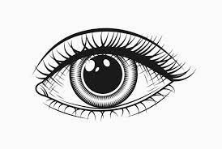

Trace an eye.

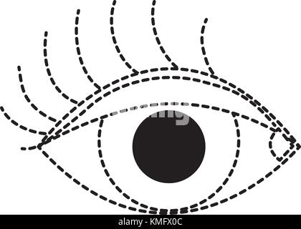

**Parents’ comment: ____________________________________________**

**______________________________________________________________**

**Signature: ____________________________________________________**

**RAPHA EXAMINATIONS BOARD**

**BABY CLASS INDIVIDUAL HOME WORK**

**HEALTH HABITS**

[raphaexaminationsboard@gmail.com](mailto:raphaexaminationsboard@gmail.com)

0778710993/0740540111



**Date:** _________________________

**My name is __________________________________________________**

**Match the same.**







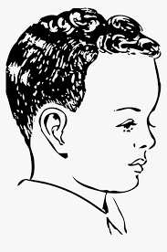













**Parents’ comment: ____________________________________________**

**______________________________________________________________**

**Signature: ____________________________________________________**

**RAPHA EXAMINATIONS BOARD**

**BABY CLASS INDIVIDUAL HOME WORK**

**LANGUAGE DEVELOPMENT II**

[raphaexaminationsboard@gmail.com](mailto:raphaexaminationsboard@gmail.com)

0778710993/0740540111



**Date:** _________________________

**My name is __________________________________________________**

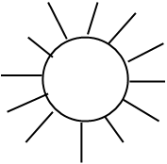

**Shade.**

s

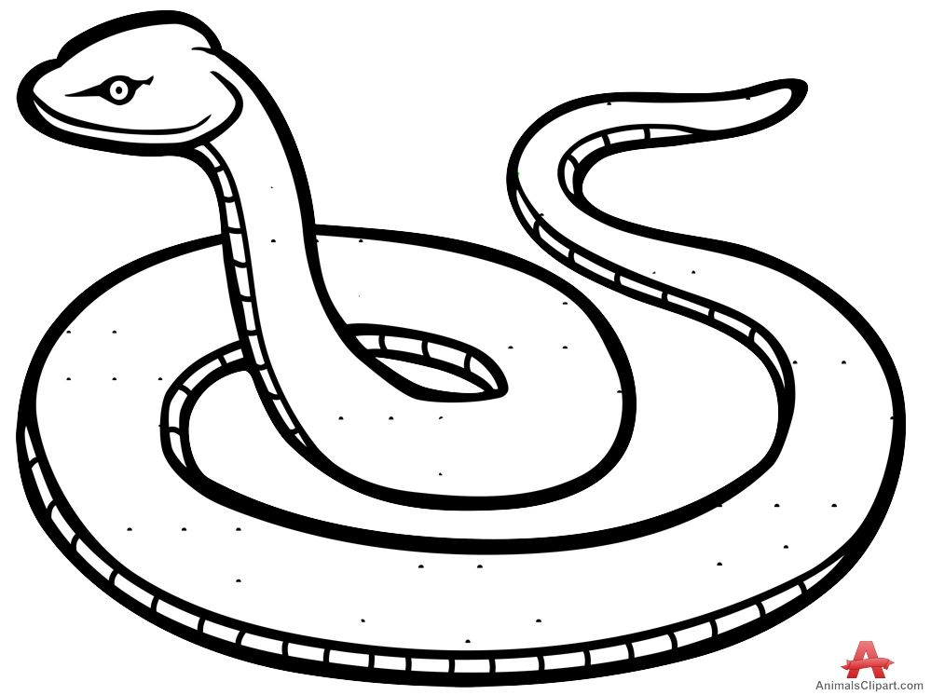

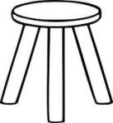

**Trace**

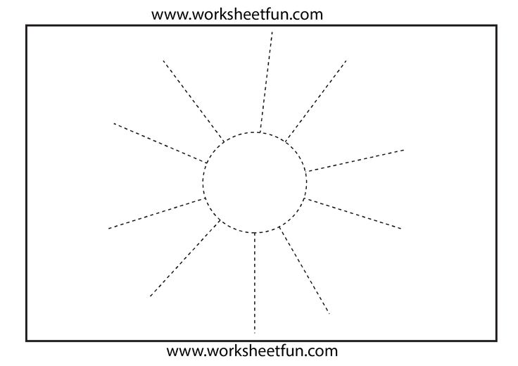



**Parents’ comment: ____________________________________________**

**______________________________________________________________**

**Signature: ____________________________________________________**

**RAPHA EXAMINATIONS BOARD**

**BABY CLASS INDIVIDUAL HOME WORK**

**LANGUAGE DEVELOPMENT II**

[raphaexaminationsboard@gmail.com](mailto:raphaexaminationsboard@gmail.com)

0778710993/0740540111



**Date:** _________________________

**My name is __________________________________________________**

**Shade.**

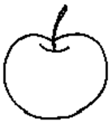

**a**

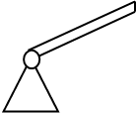

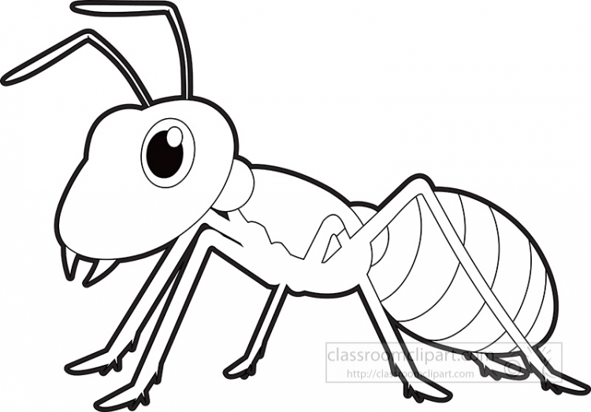

**Trace**

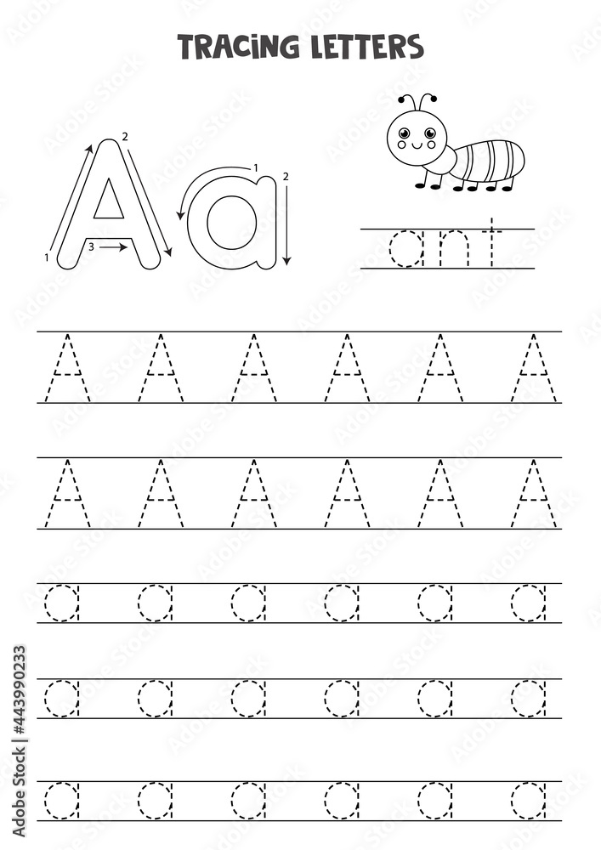

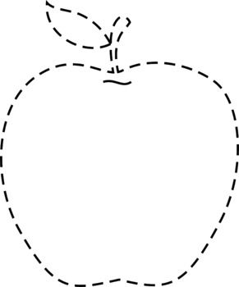 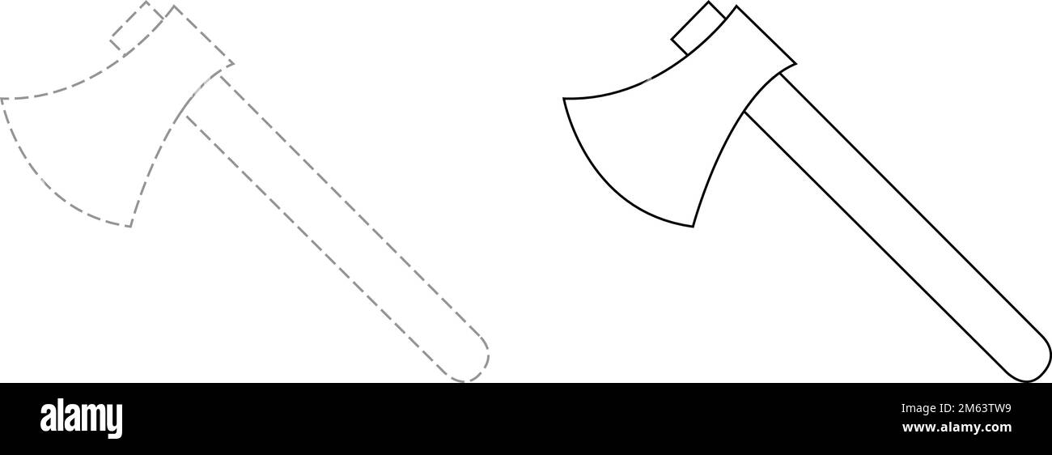

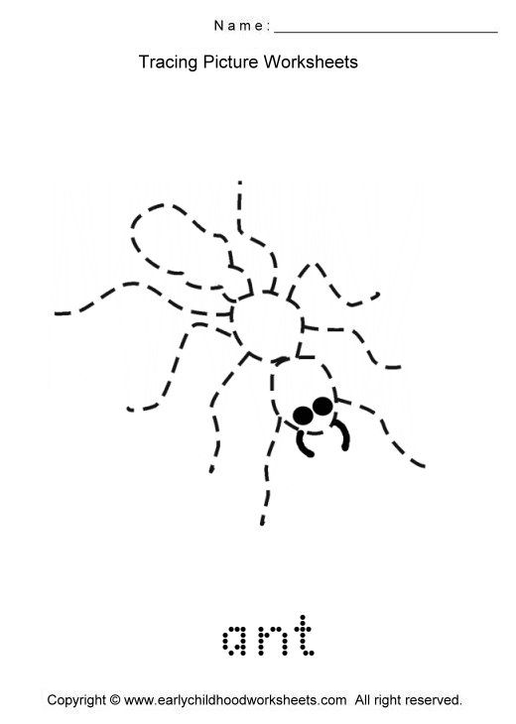

**Parents’ comment: ____________________________________________**

**______________________________________________________________**

**Signature: ____________________________________________________**

**RAPHA EXAMINATIONS BOARD**

**BABY CLASS INDIVIDUAL HOME WORK**

**LANGUAGE DEVELOPMENT II**

[raphaexaminationsboard@gmail.com](mailto:raphaexaminationsboard@gmail.com)

0778710993/0740540111



**Date:** _________________________

**My name is __________________________________________________**

**Shade.**

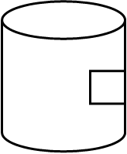

**t**

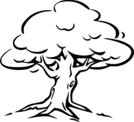

**Trace**

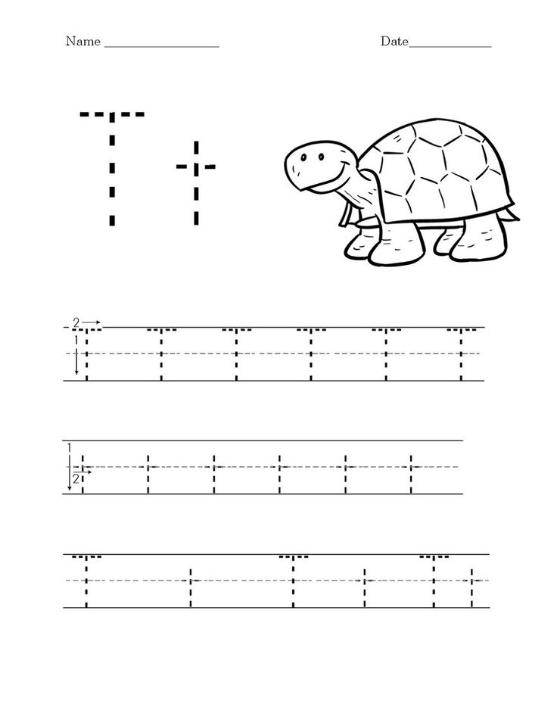   

**Parents’ comment: ____________________________________________**

**______________________________________________________________**

**Signature: ____________________________________________________**

**RAPHA EXAMINATIONS BOARD**

**BABY CLASS INDIVIDUAL HOME WORK**

**LANGUAGE DEVELOPMENT II**

[raphaexaminationsboard@gmail.com](mailto:raphaexaminationsboard@gmail.com)

0778710993/0740540111



**Date:** _________________________

**My name is __________________________________________________**

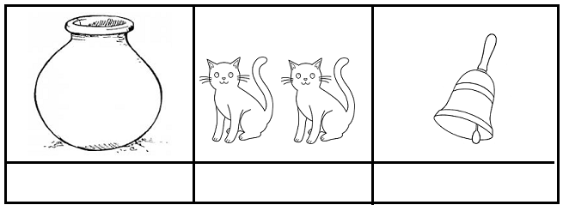**Shade.**

**P**





**Trace**

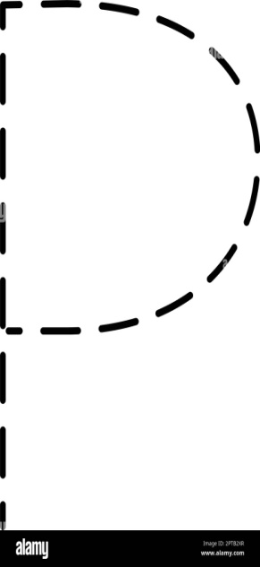  

**Trace**

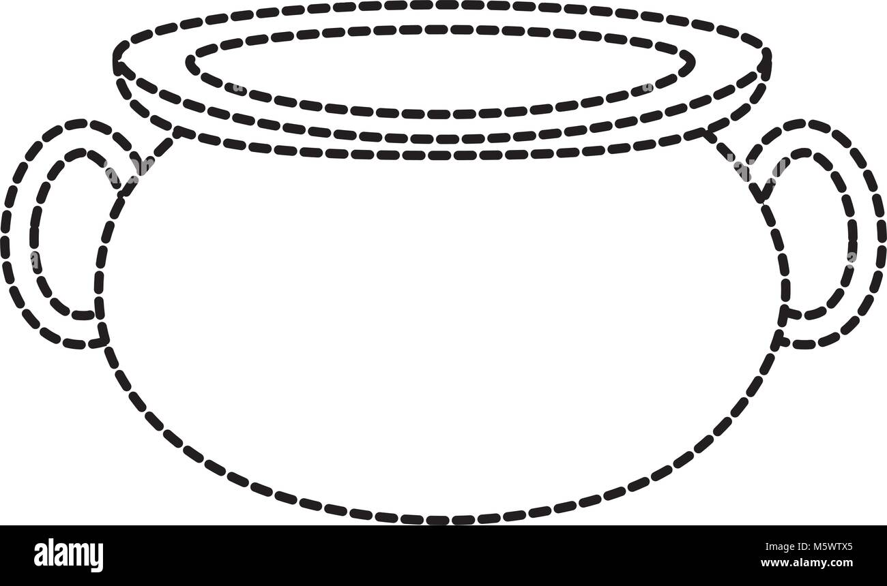

**Parents’ comment: ____________________________________________**

**______________________________________________________________**

**Signature: ____________________________________________________**

**RAPHA EXAMINATIONS BOARD**

**BABY CLASS INDIVIDUAL HOME WORK**

**LANGUAGE DEVELOPMENT II**

[raphaexaminationsboard@gmail.com](mailto:raphaexaminationsboard@gmail.com)

0778710993/0740540111



**Date:** _________________________

**My name is __________________________________________________**

**Copy.**

**________________________________________________________________________________________________________________________________________________________________________________________________________________________________________________________________________________________________________________________________________________________________________________________________________________________________________________________________________________________________________________________________________**

**Parents’ comment: ____________________________________________**

**______________________________________________________________**

**Signature: ____________________________________________________**

**RAPHA EXAMINATIONS BOARD**

**BABY CLASS INDIVIDUAL HOME WORK**

**LANGUAGE DEVELOPMENT II**

[raphaexaminationsboard@gmail.com](mailto:raphaexaminationsboard@gmail.com)

0778710993/0740540111



**Date:** _________________________

**My name is __________________________________________________**

**Match the same.**



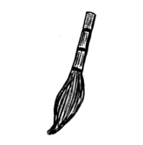

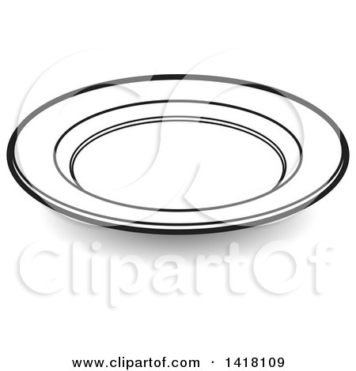











**Parents’ comment: ____________________________________________**

**______________________________________________________________**

**Signature: ____________________________________________________**

**RAPHA EXAMINATIONS BOARD**

**BABY CLASS INDIVIDUAL HOME WORK**

**LANGUAGE DEVELOPMENT I**

[raphaexaminationsboard@gmail.com](mailto:raphaexaminationsboard@gmail.com)

0778710993/0740540111



**Date:** _________________________

**My name is __________________________________________________**

**Trace things found at home.**

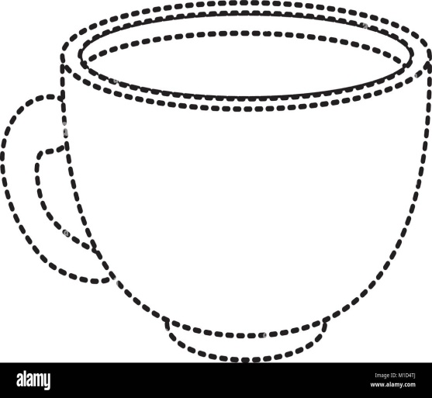

**Shade**

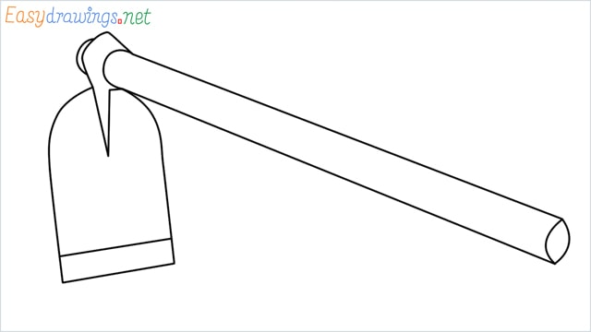

**Parents’ comment: ____________________________________________**

**______________________________________________________________**

**Signature: ____________________________________________________**

**RAPHA EXAMINATIONS BOARD**

**BABY CLASS INDIVIDUAL HOME WORK**

**SOCIAL DEVELOPMENT I**

[raphaexaminationsboard@gmail.com](mailto:raphaexaminationsboard@gmail.com)

0778710993/0740540111



**Date:** _________________________

**My name is __________________________________________________**

**Colour our home.**

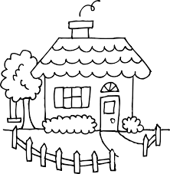

**Parents’ comment: ____________________________________________**

**______________________________________________________________**

**Signature: ____________________________________________________**



**RAPHA EXAMINATIONS BOARD**

**BABY CLASS INDIVIDUAL HOME WORK**

**SOCIAL DEVELOPMENT I**

[raphaexaminationsboard@gmail.com](mailto:raphaexaminationsboard@gmail.com)

0778710993/0740540111

**Date:** _________________________

**My name is __________________________________________________**

1. What is your name?

2. Which class are you in?

3. Hello

4. Jump

5. Clap

6. Dance

**Colour our home.**



**Parents’ comment: ____________________________________________**

**______________________________________________________________**

**Signature: ____________________________________________________**

**RAPHA EXAMINATIONS BOARD**

**BABY CLASS INDIVIDUAL HOME WORK**

**SOCIAL DEVELOPMENT I**

[raphaexaminationsboard@gmail.com](mailto:raphaexaminationsboard@gmail.com)

0778710993/0740540111



**Date:** _________________________

**My name is __________________________________________________**

**Trace our home.**

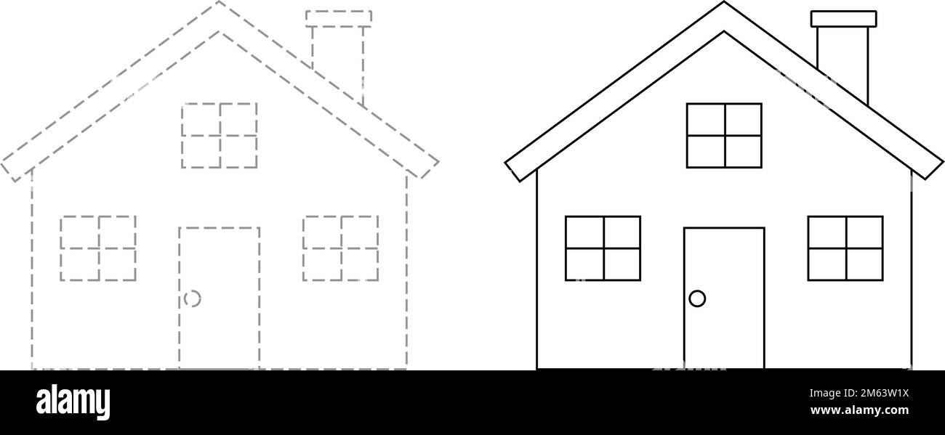

**Parents’ comment: ____________________________________________**

**______________________________________________________________**

**Signature: ____________________________________________________**



**RAPHA EXAMINATIONS BOARD**

**BABY CLASS INDIVIDUAL HOME WORK**

**SOCIAL DEVELOPMENT I**

[raphaexaminationsboard@gmail.com](mailto:raphaexaminationsboard@gmail.com)

0778710993/0740540111

**Date:** _________________________

**My name is __________________________________________________**

**Draw the same.**

|  |
| --- |
| **C:\Users\user\Downloads\trace a house.jpg** |
|  |

**Parents’ comment: ____________________________________________**

**______________________________________________________________**

**Signature: ____________________________________________________**

**RAPHA EXAMINATIONS BOARD**

**BABY CLASS INDIVIDUAL HOME WORK**

[raphaexaminationsboard@gmail.com](mailto:raphaexaminationsboard@gmail.com)

0778710993/0740540111

**BABY CLASS INDIVIDUAL HOME WORK**

**LANGUAGE DEVELOPMENT I**



**Date:** _________________________

**My name is __________________________________________________**

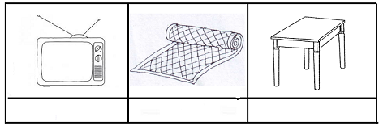**Colour things found at home.**

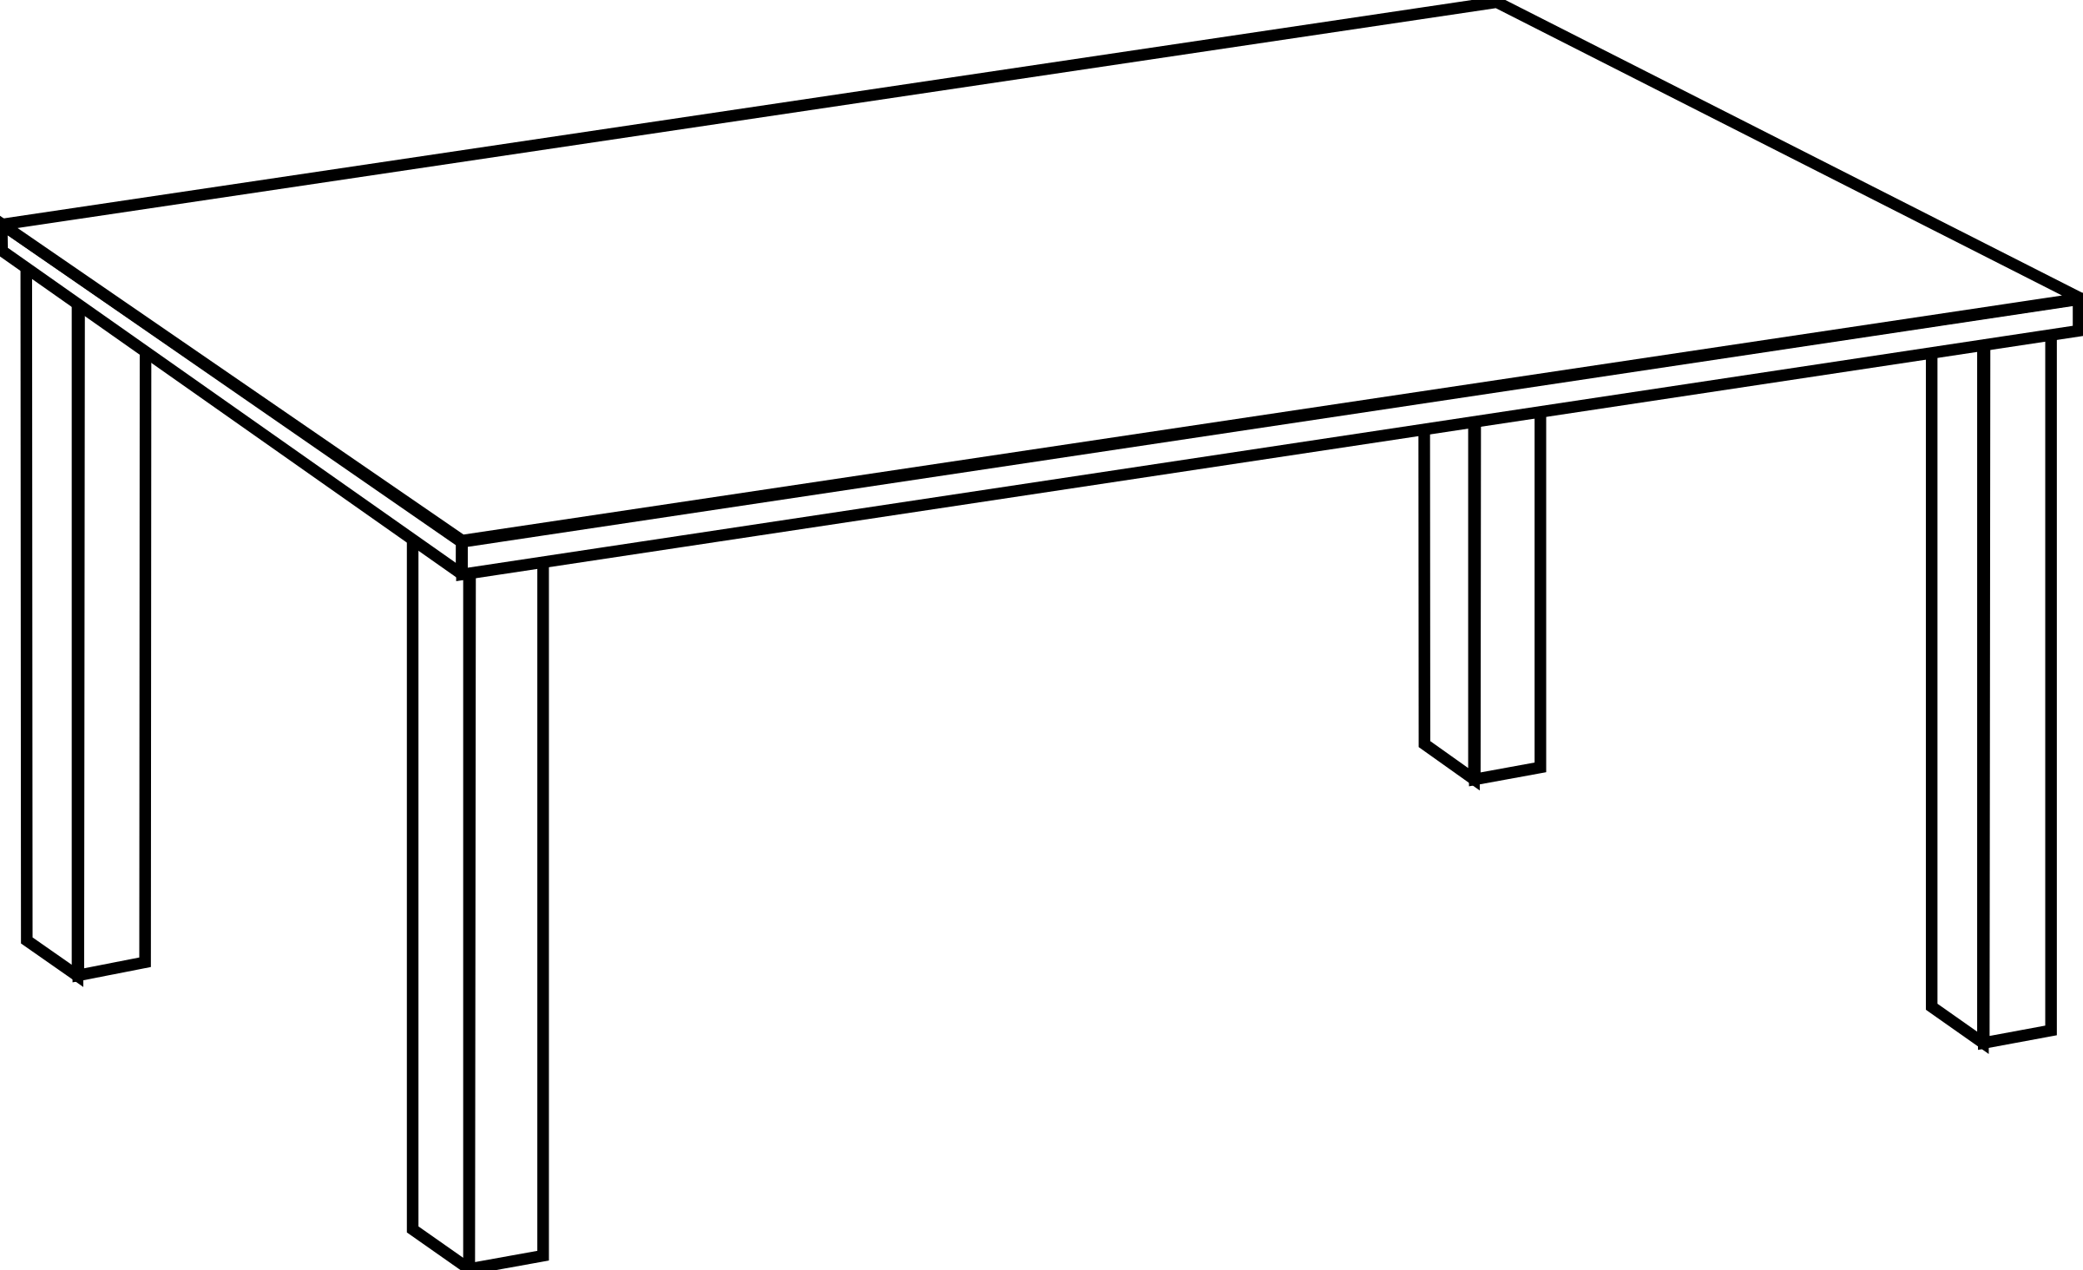

**Parents’ comment: ____________________________________________**

**______________________________________________________________**

**Signature: ____________________________________________________**

**RAPHA EXAMINATIONS BOARD**

**BABY CLASS INDIVIDUAL HOME WORK**

**LANGUAGE DEVELOPMENT I**

[raphaexaminationsboard@gmail.com](mailto:raphaexaminationsboard@gmail.com)

0778710993/0740540111



**Date:** _________________________

**My name is __________________________________________________**

**Draw the same.**

|  |  |  |
| --- | --- | --- |
| D:\2019\New folder\nursery\Nursery books images\utencils\cups.bmp |  |  |
|  |  |  |
|  |  |  |

**Parents’ comment: ____________________________________________**

**______________________________________________________________**

**Signature: ____________________________________________________**

**RAPHA EXAMINATIONS BOARD**

**BABY CLASS INDIVIDUAL HOME WORK**

**LANGUAGE DEVELOPMENT I**

[raphaexaminationsboard@gmail.com](mailto:raphaexaminationsboard@gmail.com)

0778710993/0740540111



**Date:** _________________________

**My name is __________________________________________________**

**Tell these pictures.**



**Parents’ comment: ____________________________________________**

**______________________________________________________________**

**Signature: ____________________________________________________**



**RAPHA EXAMINATIONS BOARD**

**BABY CLASS INDIVIDUAL HOME WORK**

**NUMBERS**

[raphaexaminationsboard@gmail.com](mailto:raphaexaminationsboard@gmail.com)

0778710993/0740540111

**Date:** _________________________

**My name is __________________________________________________**

**Recite.**

1 2 3 4 5

**Trace**

**Parents’ comment: ____________________________________________**

**______________________________________________________________**

**Signature: ____________________________________________________**

**RAPHA EXAMINATIONS BOARD**

**BABY CLASS INDIVIDUAL HOME WORK**

**NUMBERS**

[raphaexaminationsboard@gmail.com](mailto:raphaexaminationsboard@gmail.com)

0778710993/0740540111



**Date:** _________________________

**My name is __________________________________________________**

**Recite.**

1 2 3 4 5

**Trace**



**Parents’ comment: ____________________________________________**

**Signature: ____________________________________________________**



**RAPHA EXAMINATIONS BOARD**

**BABY CLASS INDIVIDUAL HOME WORK**

**NUMBERS**

[raphaexaminationsboard@gmail.com](mailto:raphaexaminationsboard@gmail.com)

0778710993/0740540111

**Date:** _________________________

**My name is __________________________________________________**

**Shade.**

**Trace**

**C:\Users\user\Downloads\Screenshot 2024-02-24 at 08-24-59 Page 3 - Free and customizable numbers templates.png**

**Parents’ comment: ____________________________________________**

**______________________________________________________________**

**Signature: ____________________________________________________**

**RAPHA EXAMINATIONS BOARD**

**BABY CLASS INDIVIDUAL HOME WORK**

**NUMBERS**

[raphaexaminationsboard@gmail.com](mailto:raphaexaminationsboard@gmail.com)

0778710993/0740540111



**Date:** _________________________

**My name is __________________________________________________**

**Shade.**



**Trace**



**Parents’ comment: ____________________________________________**

**______________________________________________________________**

**Signature: ____________________________________________________**

**RAPHA EXAMINATIONS BOARD**

**BABY CLASS INDIVIDUAL HOME WORK**

**NUMBERS**

[raphaexaminationsboard@gmail.com](mailto:raphaexaminationsboard@gmail.com)

0778710993/0740540111



**Date:** _________________________

**My name is __________________________________________________**

**Shade.**



**Trace**

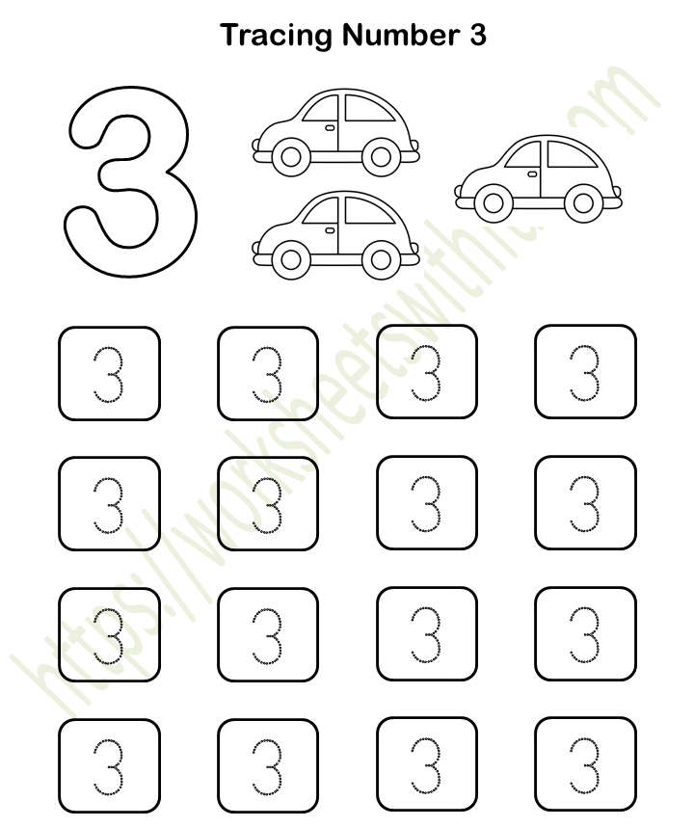

**Parents’ comment: ____________________________________________**

**______________________________________________________________**

**Signature: ____________________________________________________**